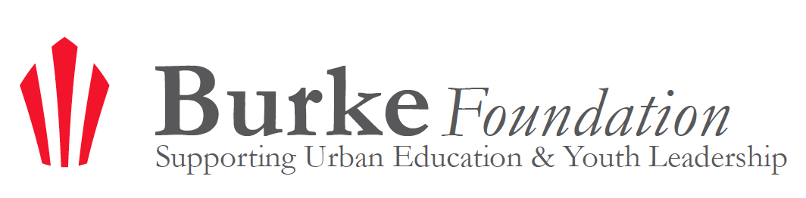

The Burke Foundation Award 2013

Please complete an online application to submit a request for funding from the Burke Foundation. Each response is restricted to a word limit noted on the question. You are able to save and come back to the application before submitting by using the "Save and Continue" button at the bottom of each page. Please note that we will only accept completed applications. Completed, electronic applications are due on Thursday, July 18, 2013 at 5 pm (CST). Applications will only be accepted through the online form found here.
If you have any questions, please read more about the award here, and feel free to consult the Frequently Asked Questions Page.
General Parameters for The Burke Foundation Award:
• Grant Amount: $200,000-$1,000,000/year
• Project must focus on youth up to age 25 and align with The Burke Foundation's mission
• Geographical Location: Metro Milwaukee
• Term: 3-5 year grants
• Will not support more than 50% of a project. In kind contributions will not be taken into consideration in determining the 50%.
• Capital and Program projects will be considered
Please note that during this application process you will be asked to upload the following documents:
☐ Theory of Change diagram. (Click here for more information)
☐ IRS determination letter of 501(c)(3) status.
Some of the items included in this application may be shared publicly. These items will be noted in the actual application.

Primary Organizational Contact Information
Company Name: ____________________________________________
Project Name: ____________________________________________
First Name: ____________________________________________
Last Name: ____________________________________________
Title: ____________________________________________
Email Address: ____________________________________________
Street Address: ____________________________________________
Apt/Suite/Office: ____________________________________________
City: ____________________________________________
State: ____________________________________________
Zip: ____________________________________________
Phone Number: ____________________________________________
URL: ____________________________________________

Application Criteria

2. Non-profit Status
Is your organization a 501c3? ( ) Yes ( ) No

3. Location
Is your organization/ project focused on youth within Metro Milwaukee? ( ) Yes ( ) No

4. Focus Area
Is your project focused on youth development and/ or urban education? ( ) Yes ( ) No

5. Have you applied for funding from the Trinity or Burke Foundation in the past? ( ) Yes ( ) No

6. Have you previously received funding from the Trinity or Burke Foundation? ( ) Yes ( ) No

Project Request

7. Duration of Project
How many years do you anticipate being funded through this grant? Grant terms can only be between 1 to 5 years.
( ) 1 year (from 2014 to 2015)
( ) 2 years (from 2014 to 2016)
( ) 3 years (from 2014 to 2017)
( ) 4 years (from 2014 to 2018)
( ) 5 years (from 2014 to 2019)

8. Total Amount Requested
For a multiple year request, please indicate the dollar amount requested each year from the Burke Foundation. Enter numbers only. For instance, if you are requesting a total of $1,000,000 for your project to be paid over two years. You would enter 500000 under 2014 and 500000 under 2015, with a total amount of 1000000.
Year | 2014 | 2015 | 2016 | 2017 | 2018 | Total Amount Requested

Amount requested per year

Request for Funding Application

9. Executive Summary
In 200 words or fewer, please explain your purpose for the project and what results you expect to achieve. Please note that this may be shared publicly.

10. Problem Statement and Goal (150 word limit)
What problem do you want to solve? Why is this the right time to tackle this problem?

11. Outcomes (150 word limit)
How do you define progress or success on this challenge? How will you know when you have succeeded?

12. Innovation (150 word limit)
How does your proposed solution differ from other efforts to solve this problem?

13. Leadership (400 word limit)
Who is the executive leader of your organization, and who are the project leaders? Please provide a brief, five sentence, leadership summary below listing relevant experience, and the length of time each has worked for the organization.

14. Validation (250 word limit)
What evidence, practical and research-based, supports your approach?

15. Opportunities (150 word limit)
What are the top two non-financial barriers that stand in the way of project success?

16. Objectives/ Action Steps (250 word limit)
What are the major milestones on the path to project success? What steps will you take to reach each milestone?

17. Youth Voice (150 word limit)
How do the young people involved in your project share their experience, needs, and feedback? Describe how youth perspectives have or will influence the project.

18. Sustainability (100 word limit)
If the approach/concept demonstrates success, how do you plan to sustain it?

19. Resources (250 word limit)
What resources, partnerships, and other inputs are needed to achieve success?

20. Assessment (150 word limit)
How will you track your progress along the way? What will you do if something appears to be off-track?

21. Evaluation (300 word limit)
How will you evaluate the progress and success of this project? What quantitative and qualitative data will you use to measure your success? How will you collect, track and use this information?

22. Burke Foundation Partnership (150 word limit)
Why are you interested in partnering with the Burke Foundation? In addition to the financial resources of the Foundation, how else might we support your work?

23. Is there anything else you would like to share with us? (85 word limit)

Funding Plan and Financials

24. Organizational Budget
Please enter your total organizational budget in the line below. Enter one number only. For example, an organizational budget of $500,000 should be completed as 500000.

25. Project Operating Budget
Enter the total operating budget for this project below. Enter one number only. For example an operating budget of $400,000 should be completed as 400000.

26. Earned Income
Enter in the earned income you expect from this project. Enter one number only.
Earned income is defined by any expected payments received through this project through the sale of goods, services rendered, or work performed.

27. Government Funding
Enter in the numerical amount of government funding you expect for this project.

28. Individual Contributions
Enter in the total numerical amount of funding you expect to receive from individuals for this project.

29. Foundation Funding
Enter in the total numerical amount of funding you expect to receive for this project from foundations.

30. Other Funding
Enter any additional sources of funding you anticipate from this project below. For example, if you are planning on receiving $20,000 from the XYZ Corporation, enter the XYZ Corporation for "Funding Source 1" and 20000 on the right column.
 | Funding Source | Amount of Project Funding

Funding Source 1

31. External Funding
Enter in the percentage of funding from the various funders below that you expect to receive for this project. Total should equal 100%.
Funder | % of Project Funding

Government

Foundation

Individual

Corporation

Other

32. Committed Funding (50 word limit)
List the top funders who are already committed to funding this project.

33. Line Item Expenses
List the top 15 line item expenses (operational and project based) into the table below. List one expense per line and the amount you expect to pay for this expense in the right column.
Expense (e.g. salaries, rent, marketing, etc.) | Expense Amount (e.g. $5000)

Application Uploads

Please upload all requested documents in PDF format. Because of the upload functionality, these questions may not be viewed properly on a mobile device. Please upload only one PDF file per question.
☐ Theory of Change diagram. (Click here for more information)
☐ IRS determination letter of 501(c)(3) status.

Feedback

Please give us any feedback you have on this application process below. Thank you for your comments!

Thank you for completing the application for The Burke Foundation Award.
Feel free to submit any questions you may have here.
Thank you for your interest in The Burke Foundation!

